

UNIVERSITY OF NAIROBI

COLLEGE OF BIOLOGICAL AND PHYSICAL SCIENCES

SCHOOL OF COMPUTING AND INFORMATICS

A WEB BASED ONLINE COURSE EVALUATION SYSTEM

Bernard Siele

Elisha Opiyo

Gureya Daharewa

W. Okelo-Odongo

OCENA: ONLINE COURSE UNIT EVALUATION SYSTEM

# Introduction

In the University of Nairobi ISO-2009 quality manual (QM), one of the important procedures included is the procedure for Teaching. That procedure provides for course evaluation by students which is an important feedback mechanism for quality assurance. The university uses this mechanism to monitor the execution of the curriculum delivery function. The focus is on aspects such as inputs, lecturer effectiveness, relevance, etc.

## Course evaluation

Course evaluation is intended to be carried out for each course unit independently. It is carried out twice, namely, around the middle of the semester and towards the end of the semester. Course evaluation process is conducted by the course coordinator appointed by the head of the teaching unit.

Each of the students who have or are taking a course unit is expected to independently and anonymously assess the unit using a provided form. Some of the aspects are assessed using a Likert scale while some call for free form comments.

The assessments from all the students are required to be analyzed and feedback given to the head of the academic unit and the concerned lecturer. Students should also receive feedback.

Currently the process has been conducted largely manually.

## Automation of Course evaluation

Ocena shifts course/lecturer evaluation to the latest technological approach where the evaluation becomes easier, quicker and more efficient. Ocena is a complete web-based system for administrators, students majorly to help improve the quality of evaluation analysis, improve the way the evaluation is done and quicken the process of generating evaluation report. It has flexible features that support multiple users and schools/faculties/institutes or departments, enabling them perform evaluation, mark them and generate reports based on these. Besides that, Ocena is able to keep history of the previous evaluations.

# System users and user roles

## Roles

From section 1.1 above, the main users of the evaluation system are: students, course coordinator, head of teaching the teaching unit (Director, Dean and Chairman) and the lecturer. A system administrator is also required to be responsible for system management.

Administrator

Amongst other evaluation system management functions, the admin maintains information about degree courses/programs, course units, departments, schools, faculties, colleges, and teaching department heads.

Teaching department head

Assigns course coordinators. Receive the course evaluation analysis reports. Prepares feedback to lecturers. Prepares feedback to students

Course Coordinator

Prepare an evaluation session including course units to be evaluated, lecturer information, students with rights to do evaluation. Do analysis. Prepare reports for the HOD.

Student

Evaluate course units. Receive feedback from HOD.

Lecturer

Receive feedback from HOD. Prepare acknowledgement and response to HOD.

## Process map

Evaluation session closed (system assesses the evaluation)

Students perform evaluation

Evaluation session created

Reports generated and downloaded

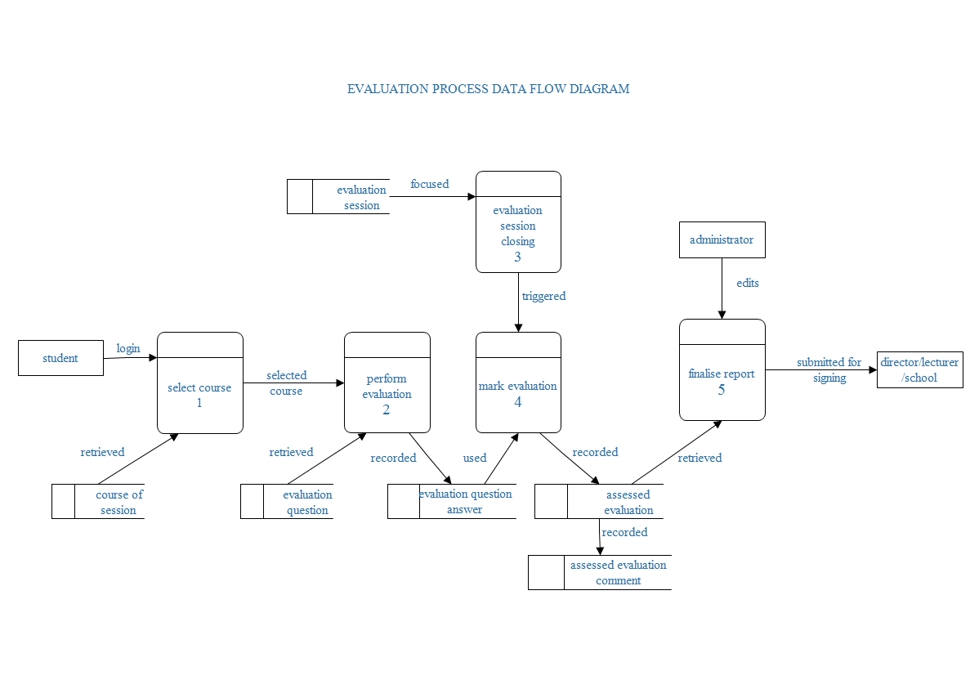

# 3. Current implementation

## Users and roles

Ocena is a multiuser web application that supports various user groups, common ones including: student, lecturer and other staff.

Adding a user is available to the faculty/department and system admin on clicking the users tab and subsequently add user submenu.

Each user can have faculty member role which determine Ocena tasks regarding the faculty/department that can be performed on them, e.g. a lecturer can be evaluated upon.

Each of the user groups can be set to have different roles and access to the system. This is to say, a member of the other staff can be set to have faculty/admin rights to the system; hence can set up evaluation and coordinate evaluation sessions.

The right to upgrade and downgrade a user’s group and/or faculty member role is available to the faculty/department and system admin on clicking the users tab and subsequently upgrade user submenu.

Briefly, users in the student faculty member role can perform course/lecturer evaluation. Correct admission year must be provided for the student to perform evaluation under the supposed evaluation session. Failure to do this lets the student to perform evaluation of courses they did not do or deems the student unable to perform evaluation at all.

Users in the lecturer faculty member role can be matched to a course while adding courses of session to an evaluation session. Doing this creates the impression that the course of the evaluation session was taught by such user [course was taught by the user with faculty member role in a particular semester].

Users in the admin faculty member role can perform all tasks pertaining and not limited to evaluation sessions, handling evaluation prerequisites.

The system admin is a special user group designed to make settings that are vital to the usage of the system, such including setting up the institution, colleges, faculties/schools/institutes and departments. The system admin can add and upgrade users. They can also handle evaluation prerequisites, evaluation sessions excluded.

## Setting evaluation prerequisites

The system admin can perform the creation, retrieval, editing and deletion [CRUD] on the institution and its colleges. They can do the same on faculties which belong to the colleges and subsequently, departments if any of those faculties. The department or faculty depending on whether the departments exist or not is the lowest unit of hierarchy in Ocena setup. Each department and faculty (if the faculty has no departments) has rating values, question categories, evaluation questions, admissions and degrees. The evaluation questions and degrees are unique to a department or faculty.

Users in the system admin user group and admin faculty member role can perform all tasks pertaining to handling evaluation prerequisites. These tasks include the creation, retrieval, editing and deletion [CRUD] of rating values, question categories, evaluation questions, admissions and degrees. For each degree, they can perform the aforementioned tasks (CRUD) on courses. That is, courses offered in each degree.

The features mentioned above are available at the faculty/department home for the faculty/department admin and faculty/department dashboard for the system admin. These are lined up in accordions. Each accordion panel lists these features and for each, there are two buttons: one for editing the feature and the other for removing the feature. One add button per panel appears below the list of these features.

Request to add a feature[ on clicking the add button ] a dialogue pops up where in you fill in the values as lined up and click to add to submit. The list will update and the dialog fields will clear awaiting input of next item. The edit feature works in the same way, only that its dialog closes on save. The remove button prompts the user to confirm request.

## Evaluation sessions

Any *create, retrieve, edit and delete* [CRUD] action involving evaluation sessions is specifically set apart for the faculty/department admin.

An evaluation session is the period where evaluation of particular courses/lecturers can be done. This is set up by the faculty/department admin. They specify the start and end date of the sessions, the degree whose courses are to be evaluated, the current academic year and semester and then the admission month and year in the form[ Jan 2014 ].

The admission month and year defines the group of students who can perform the evaluation of courses specified in any given evaluation session. This, therefore, is definitely a significant specification whose incorrect entry would deter a group students a chance to perform the evaluation or allow an unintended group of students to do so. This goes on to point that on addition of a user who is a student, great care must be taken to ensure that the correct month and year in which the student was admitted be entered in the form[ Jan 2014 ].

Nevertheless, a repeating student, preferably, can edit their admission month year to match that of the group of students they are studying with in order to be in a position to perform the evaluation with the rest of the group.

Courses of session are specified for every evaluation session by the faculty/department admin. Once an evaluation session is created, a course is matched with the lecturer who taught it and when this selection is submitted, a course of session is thence successfully created. This is done for all the course a group was taught in a semester [since an evaluation session should allow for evaluations of courses taught to a group in a semester].

## Performing evaluation

Once an evaluation session has been set up and courses of session defined, the students can then be asked to perform evaluation. The students just log in, click on the evaluation tab and select the admission [graduate or undergraduate], then the degree [e.g. B.Sc. Computer Science]. They then select the courses one by one while evaluating upon and submitting upon it when completed. The student will receive a confirmation of completion of evaluation for each course. When all courses of session are evaluated upon by a student, they receive a message informing them that they have completed the evaluation and that their feedback is appreciated.

## Evaluation reports

Evaluation reports are the documents containing the information passed on by the students.

For each course of session there are three such documents: evaluation report, evaluation summary report and general comments report.

The evaluation report contains the rating or percentage value given by the student for each question answered by giving such values. The evaluation summary table contains a table that summarizes the evaluation based on question category. The general comments report is a dump file for all comments and reasoning made and written by the students.

The evaluation reports are downloaded by clicking on the download menu and subsequently the download reports submenu at the faculty/department home for faculty/department admin and faculty/department dashboard for the system admin.

Prior to the downloading, the faculty/department admin shall have closed the evaluation session in focus. On prompting the system to close an evaluation session, the system assesses the evaluation performing the necessary calculation and computation to produce assessed evaluations. The system then generates the aforementioned reports and saves them in a folder called “Evaluation reports” in the root folder of the system, that is [$CATALINA_HOME/webapps/Ocena/]. The evaluation session is then deactivated.

A zip file is created when the system is prompted to download reports. This is the file that will be downloaded. The reports for each course of session are well placed within the archive in a fashion like so: [Evaluation reports/Academic year/Course code/Staff number/Semester/].

## Screenshots

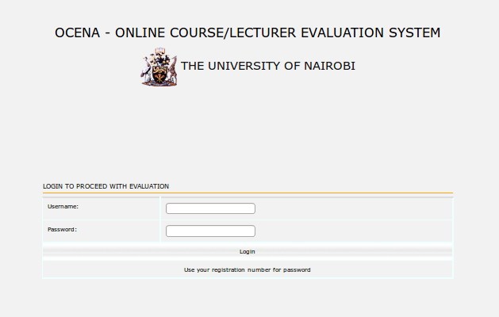

Figure 1: Login page

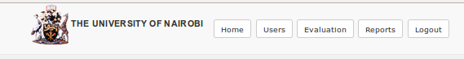

Figure 2: Menu bar

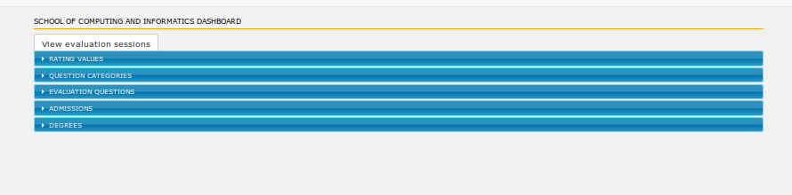

Figure 3: Evaluation prerequisites

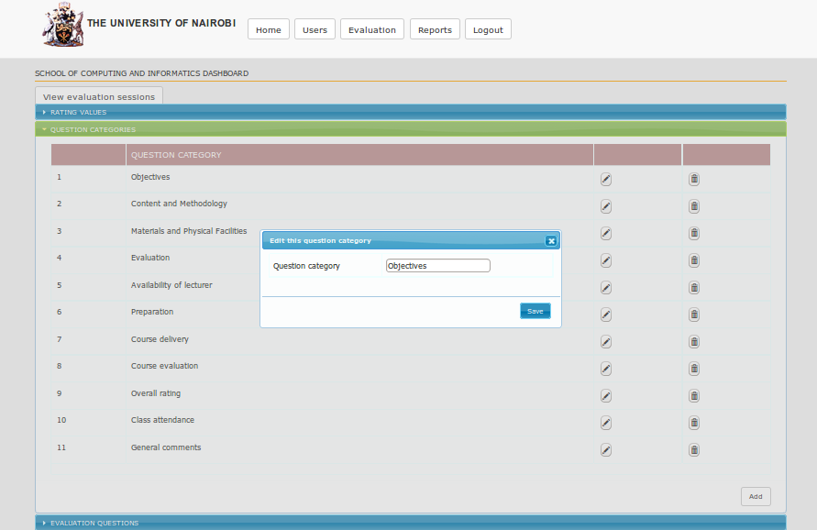

Figure 4: Add dialog

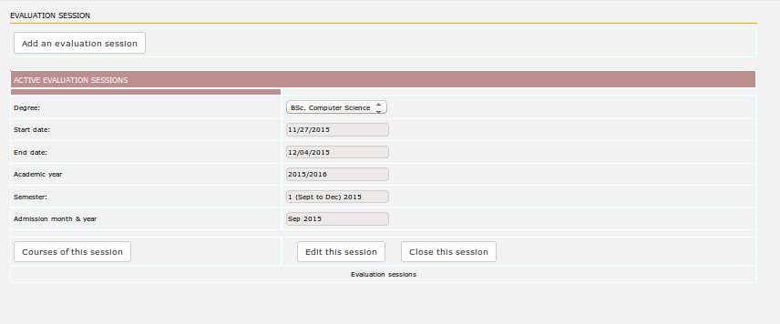

Figure 5: Evaluation session

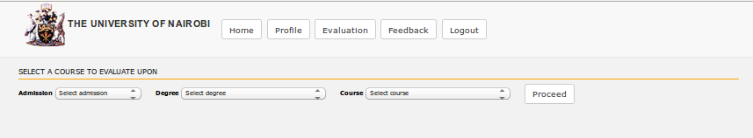

Figure 6: Choose course to evaluate upon

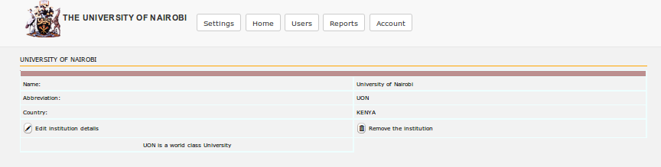

Figure 7: Institution

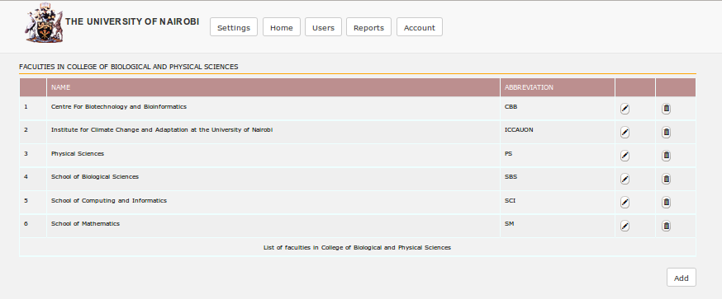

Figure 8: Faculties

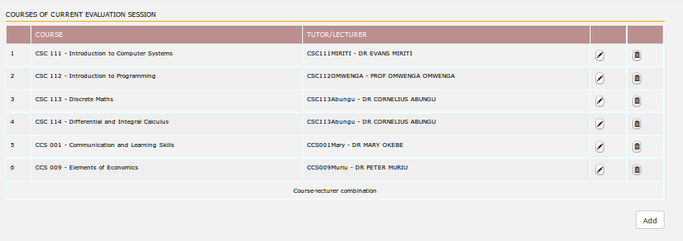

Figure 9: Courses of session

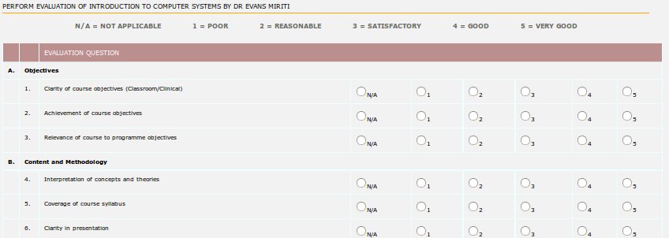

Figure 10: Perform evaluation